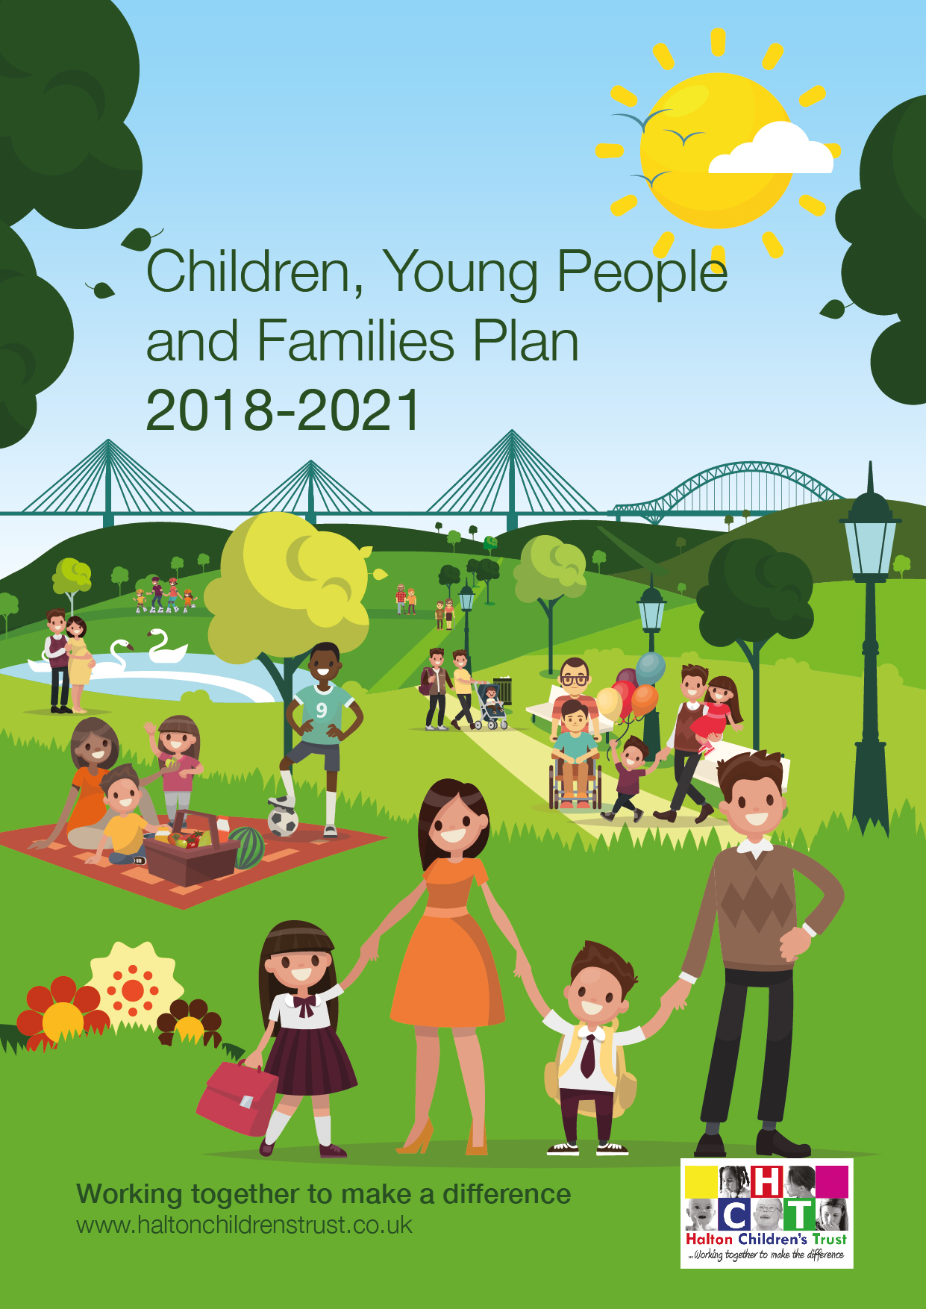
CONTENTS

Forewords 3
What is Halton Children’s Trust? 4
What is Halton Children, Young People and Families Plan (CYPP) 4
Our Vision 5
Local Profile 6
National Context 7
What were the Key Achievements from the CYPP 2014-17? 8
What are Halton’s priorities? 10
1. Early Intervention 10
2. Achievement and Ambition 11
3. Healthy and Safe 12
How we intend to work together to achieve this? 14
Glossary 15

Forewords

Councillor Tom McInerney
Lead Member Children, Young People and Families Chair, Halton Children’s Trust Board

The future success of Halton depends on our children and young people and we have high aspirations for them.

This new Children and Young People and Family Plan marks a significant step forward in our collective ambition and efforts. We will continue to put children and young people at the heart of what we do to ensure that their needs are understood and met, and that they have clear ways to hold us to account for our decisions.

This will only be achieved if everyone plays their part, and contribute to several of the outcomes we are seeking to improve.

Led by Halton Council, the Children’s Trust brings together key strategic partners who have the ability to bring about change, working together on shared ambitions; we can make the difference that is needed.

Welcome to our new Children and Young People’s Plan. We believe it is important that children and young people, who are our most precious asset, know that if we work well together, listen to them that we will be more able to help every single one of them to grow into confident and successful adults.
Everybody knows that these are challenging and uncertain times, reductions in funding, changes to the way organisations are structured and the impact and expectation of living in a digital world. It is, therefore, more important now than ever that we work in genuine partnership; that we do not retreat behind organisational boundaries or start cutting services without consultation or forethought.
We recognise that although most children and young people already experience a loving upbringing and benefit from a great education that is not true for everyone. Our commitment and focus must be to help children have the resilience and aspiration to be the best that they can be and their futures are not determined by post code or family circumstances.
Our priorities are based on clear evidence about what is needed and what works, and crucially are driven by what children and young people themselves have told us.
The families, children and young people I have met through my work never cease to amaze and impress me with their energy, optimism and enthusiasm for life. I would like to thank them for reminding me what is important in life.
Finally, I hope you find this plan readable and that its recommendations make sense to you.

Milorad Vasic
Strategic Director People, Halton Borough Council

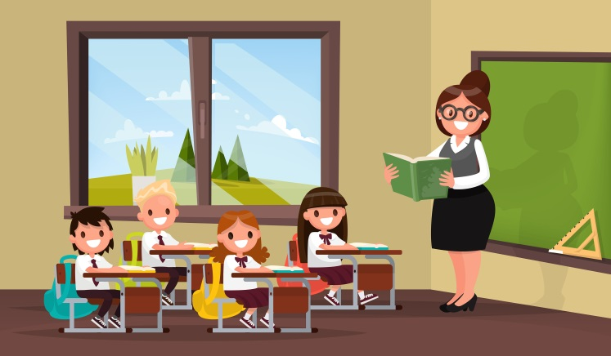
What is Halton Children’s Trust?
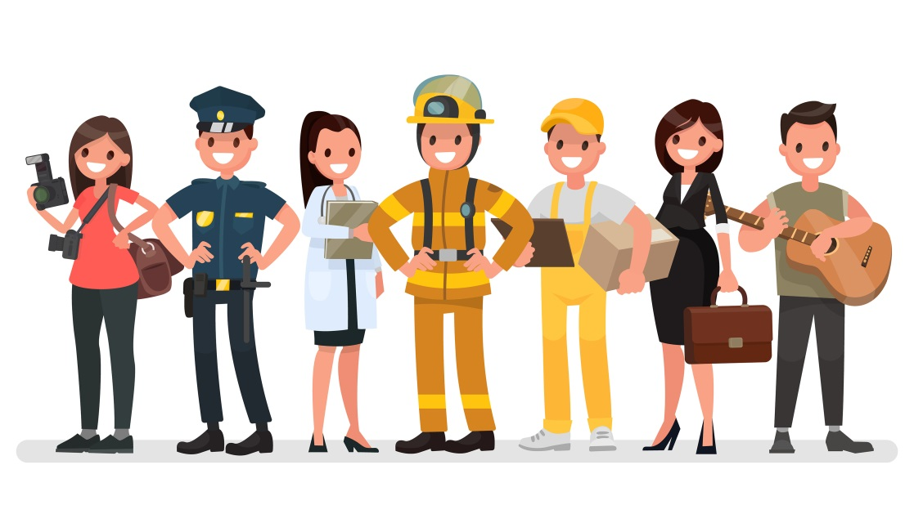
Halton Children’s Trust was established in 2008, it is a partnership of all the different people that work with children and young people and their families.

Members of the Trust include Teachers, Police Officers, Youth/Social Workers Health professionals as well as local community groups including parents and carers.

What is Halton Children, Young People and Families Plan (CYPP)
The Halton Children, Young People and Families Plan is the main plan for all partners within Halton Children’s Trust, it describes what we will do in Halton by agreeing on a set of priorities and take collective responsibility for improving the outcomes for every child and young person to ensure that regardless of their circumstances, they will have access to the best services. The Plan is based on a needs analysis, including the Joint Strategic Needs Assessment; consultations with partners, stakeholders, staff, parents and carers; and most importantly children and young people themselves.

We want them to realise their full potential, have high ambitions for themselves and their neighbourhoods and to become adults who help to drive the prosperity and success of Halton.

Our Vision
“Halton’s ambition is to build stronger, safer communities which are able to support the development and learning of children and young people so they grow up feeling safe, secure, happy and healthy, ready to be Halton’s present and Halton’s future”
Our vision isn’t something that any one organisation or group of people can make happen on their own. For this Plan to work, all of us need to work together. This includes parents, the Council, schools, health, police, voluntary sector and most importantly, young people themselves.

We plan to achieve our vision through having clear goals which we measure, making sure that all partners are working together to achieve the outcomes we need.

In this Plan we set out our priorities for children, young people and families, how we aim to achieve these, who is responsible and what our success will look like.
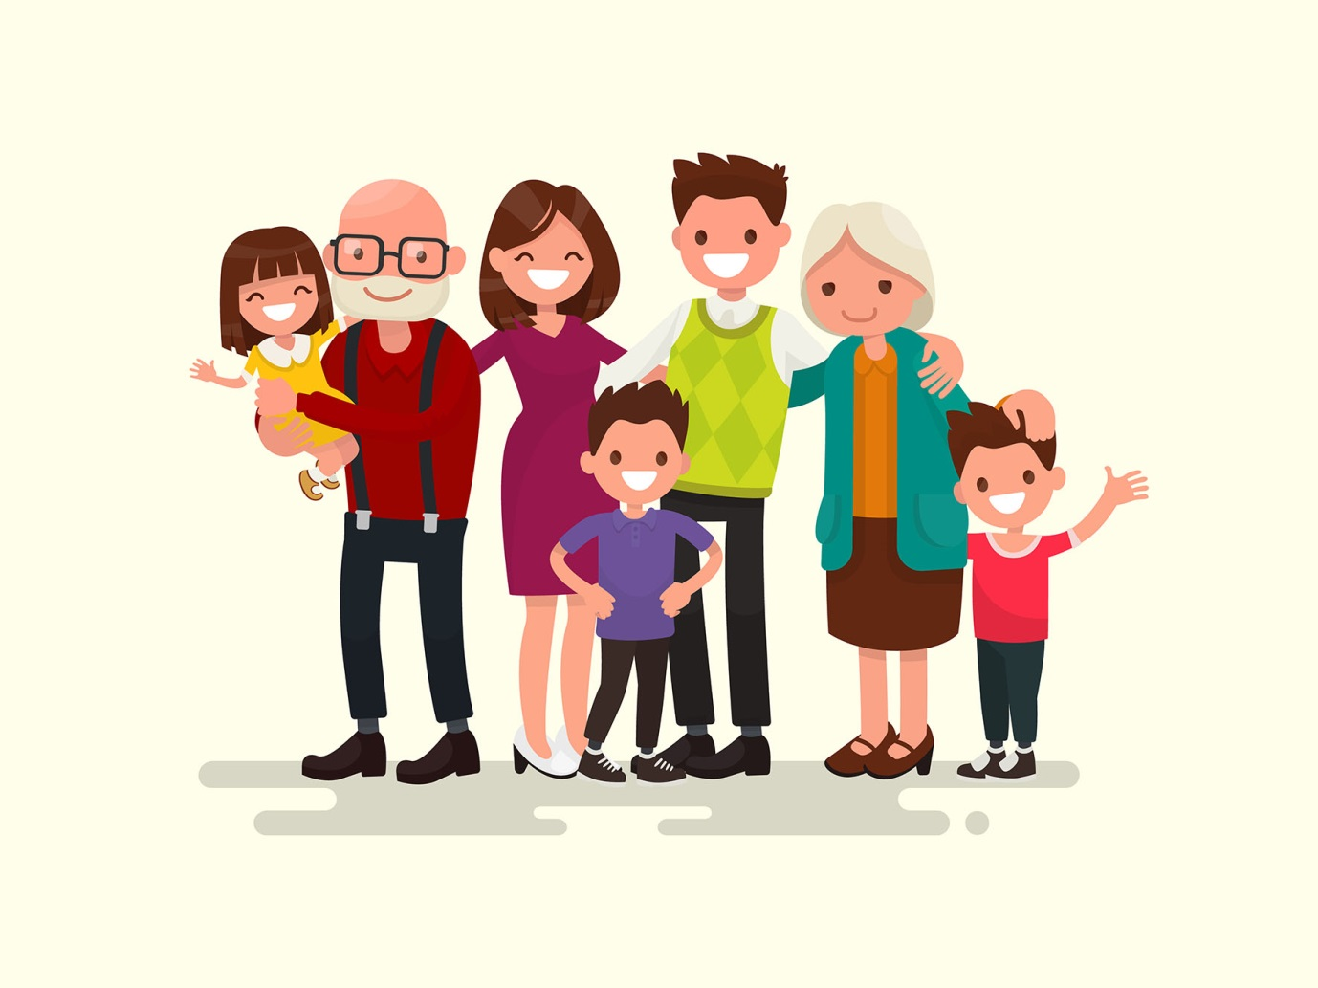

Local Profile
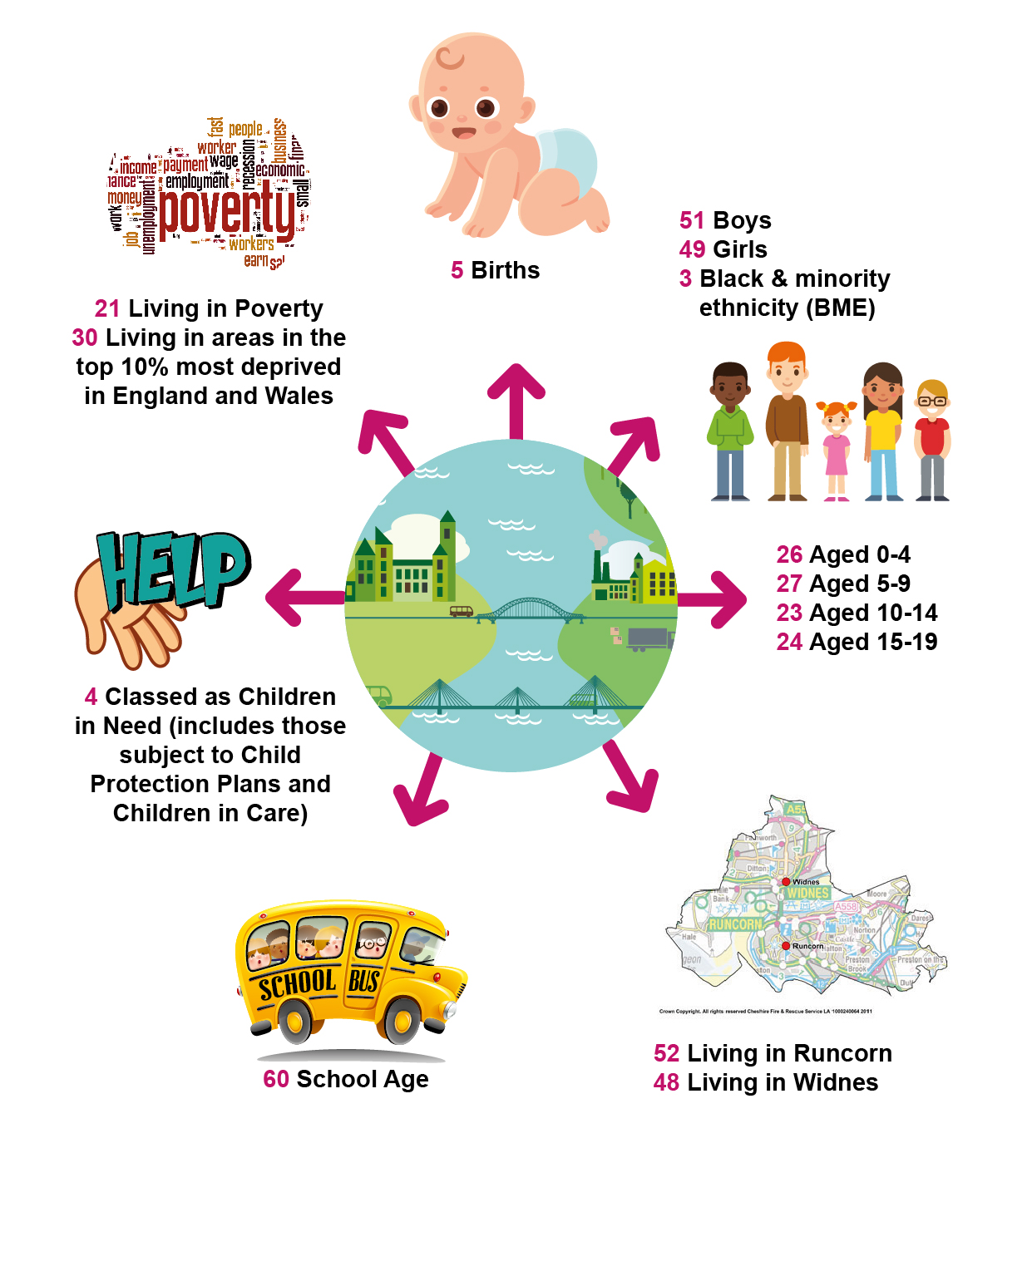
If Halton was a village of 100 Children and Young people

National Context
This Plan has been developed against a background of a rapidly changing set of national expectations, a wide ranging education and social care reform programme and public spending cuts.
Healthy Child Programme for early life stages focuses on a universal preventative service, providing families with a programme of screening, immunisation, health and development reviews, supplemented by advice around health, wellbeing and parenting. It highlights the key role in improving the health and wellbeing of children, as part of an integrated approach to supporting children and families.

The Children and Social Work Act 2017 introduces a number of new requirements for local authorities and providers. Key areas are:
- Corporate parenting principles and children in care duties.
- Education duties to previously looked after children.
- Care leaver duties expanded.
- Abolition of safeguarding children boards.
- Further regulation of social work.
- Compulsory relationship and sex education in schools.

The Wood Review in May 2016 set out recommendations for making local safeguarding children boards (LSCBs) more effective. https://www.gov.uk/government/uploads/system/uploads/attachment_data/file/526329/Alan_Wood_review.pdf

This included reducing the number of agencies who had to be a part of the board to just the local authority, the police and health.

Changes to LSCBs are incorporated into the Children and Social Work Act 2017. It is expected that LSCBs will retain current functions until the end of March 2018.

The Children and Family Act 2014, The Care Act 2014 and The Single Equalities Act 2010 form the backbone of SEND Reforms, offering simpler, improved and more consistent help for children and young people with SEND.
The new system extends the rights and protection to children and young people by introducing education, health and care plans and extending provision from birth to 25 years of age. The reforms came into force in September 2014.

The Education and Adoption Act 2016 gives Council’s three key roles in education for children, young people and families

- Making sure every child has a school place.
- Ensuring the needs of all vulnerable pupils are met.
- Acting as champions for children and families.

The Act also gives new powers to arrange adoption.

What were the Key Achievements from the CYPP 2014-17?

Integrated Commissioning

- A range of specialist provision sourced to meet the needs of families.

- Family Nurse Partnership established to support to young first time mothers to make informed decisions enabling a healthy pregnancy and lifestyle.

- The first phase of the 'inspiring families' programme assisted 375 families by getting children back into school, reducing anti-social behaviour/youth crime and getting them on the pathway into work.

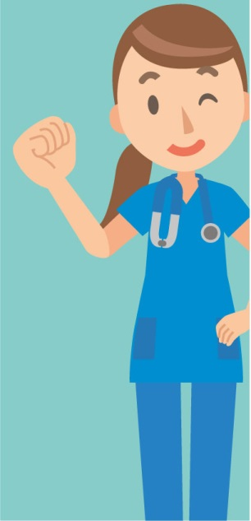
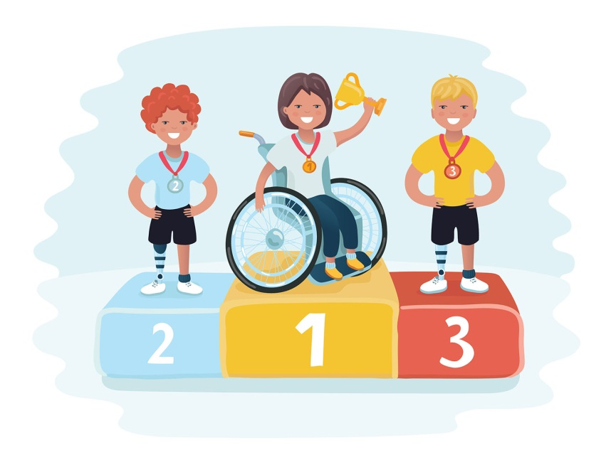
Closing the Gap

- Schools and early years setting are improving by getting a good or better Ofsted rating.

- Special Educational Needs and/or Disability (SEND) Local Offer website was introduced to provide information, support and advice across a range of services available for everyone.

- Improved data management systems to analyse results and target support to schools/ settings to help close the gap for disadvantaged pupils.

Early Intervention

- A multi-agency integrated Contact and Referral Team (iCART) was developed providing a single point of contact in Halton for concerns around child welfare and families requiring support.

- Integrated 2-year check developed to identify children who are not progressing towards their early learning goals.

- Worked with families to support them in making healthy choices e.g. breastfeeding, introducing solid food, getting families active and building positive emotional health and wellbeing.

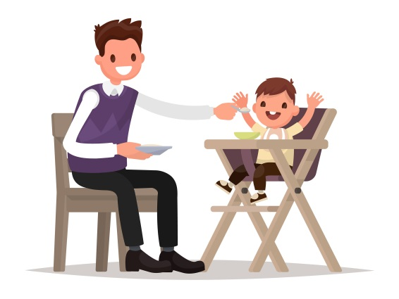

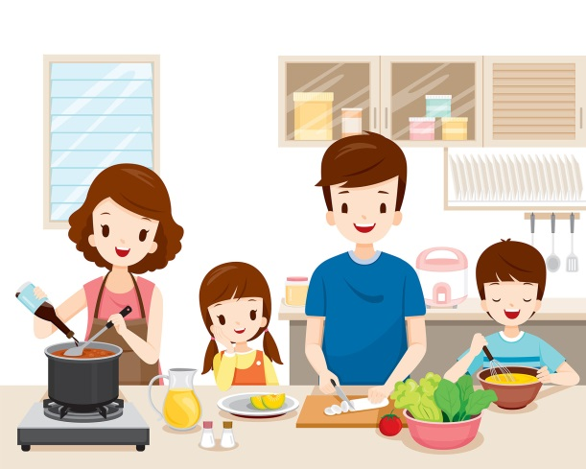

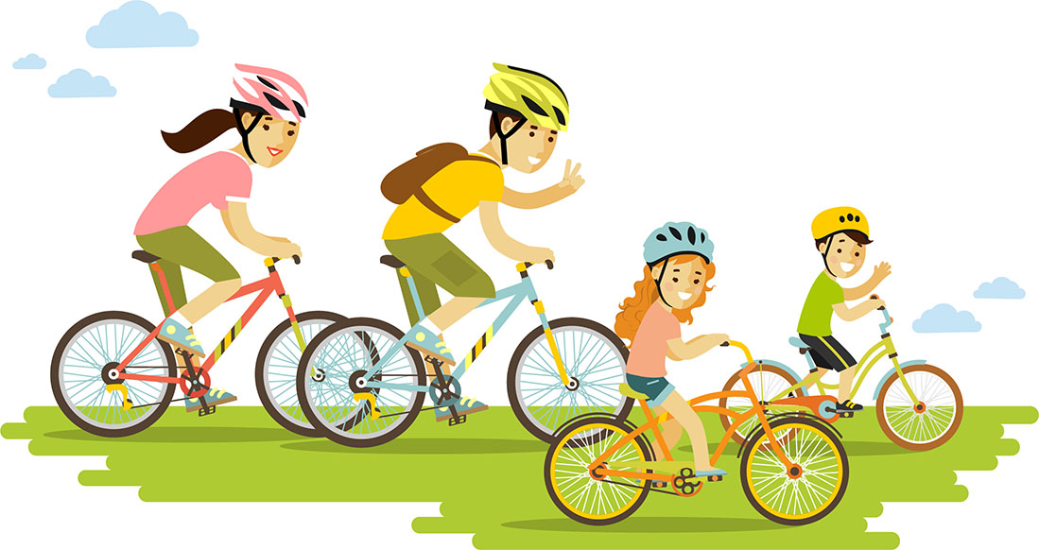

What are Halton’s priorities?
We think that to make it better for all children, young people and families in Halton we need to work together on these 3 areas:

Early Intervention

If families don’t get support at the right time, problems become harder to sort out.

We want you and your family to get help when you need it.

The principle of intervening early to prevent problems emerging at a later date is one that we continue to work on. Effective early intervention will resolve problems before they become overwhelming and require high cost, reactive services. There are two inter related strands to Early Intervention. The first is to provide help and support at the earliest stages of a child’s life (pre-birth to school age). We know that very early childhood experiences can shape a child’s future life chances, and that adverse experiences in the early years can continue to affect children into adulthood. The second is early Identification of any problems and of children who may not be reaching their developmental milestones or where there are emerging concerns is essential throughout their childhood. We remain committed to the provision of effective early help on a multi-agency basis, and are investing in new models of delivery.
Areas of Focus:
- Intervene at the earliest opportunity with identified families

- Ensure they are prepared for parenthood to parent effectively

- Monitor and review the effectiveness of iCART

- Establish and implement a multi-agency locality provision

- Investment in staff to ensure consistent quality across all our work with vulnerable children and young people

Achievement and Ambition

Young people want to do as well in exams as they do in other parts of the country.

We want you to do well at school so that you can get the education, training or job that you want.
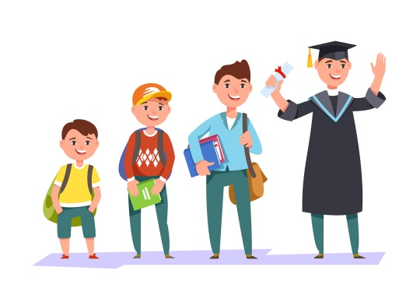
We need to prepare our young people to be adaptable, resourceful and raise their ambitions so that they can benefit from opportunities as they arise. Improving education outcomes is essential so that they do well at all levels of learning, have the skills for life for them to be successful in the future to get the training and/or job that they want.

Areas of focus:
- Raise achievement in early years

- Raise attainment and progress at Key Stage 2

- Improve the offer for children and young people with SEND

- Improve participation and skills post 16 for young people to drive Halton’s future

Healthy and Safe
Young people want to feel healthy and safe at school, at home and in their community.

We want you to feel safe wherever you are and to understand how to look after your health.

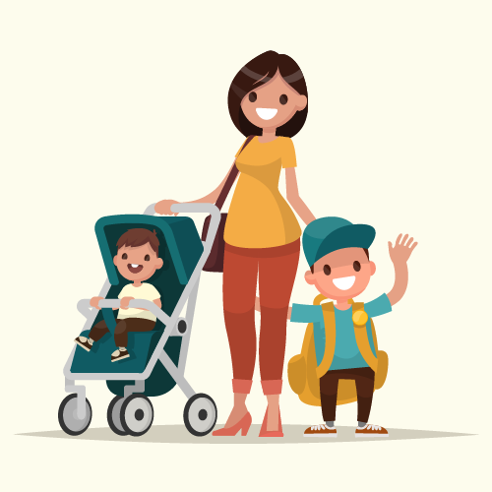
To help Halton children and young people to be happy and healthy we know that we have to work with families as early on as possible, ideally even before conception.
By supporting families to have a healthy pregnancy and early years babies will grow up and develop in a nurturing environment, laying down strong foundations for the rest of their life and ensuring children are ready for school.
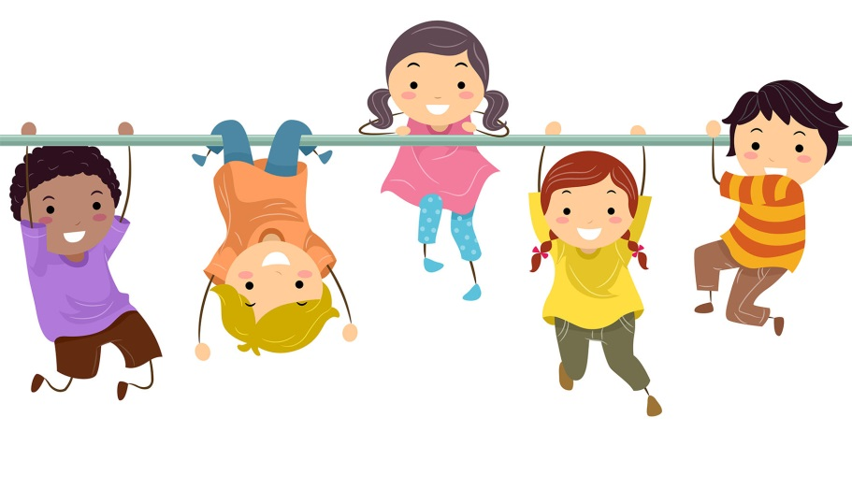

Helping families to make healthy choices supports children to be happy and to learn. We know it can be difficult and working to reduce child poverty, support healthy eating, active play, physical activity and minimising harmful behaviour such as alcohol are all important for children and young people’s success.

Areas of focus:
- Give every child the best start in life and support good early child development

- Get everyone more active, eating healthily and reduce harm from alcohol

- Promote emotional wellbeing, and improve early detection and treatment for mental health problems

- To reduce victimisation, criminality and anti-social behaviour within the school communities

- To deliver appropriate key prevention messages to all young people including on line safety, personal safety and good citizenship

- To divert children and young people away from the formal criminal justice system and into more appropriate treatment when health and other unmet needs are the primary causes of low level offending behaviour

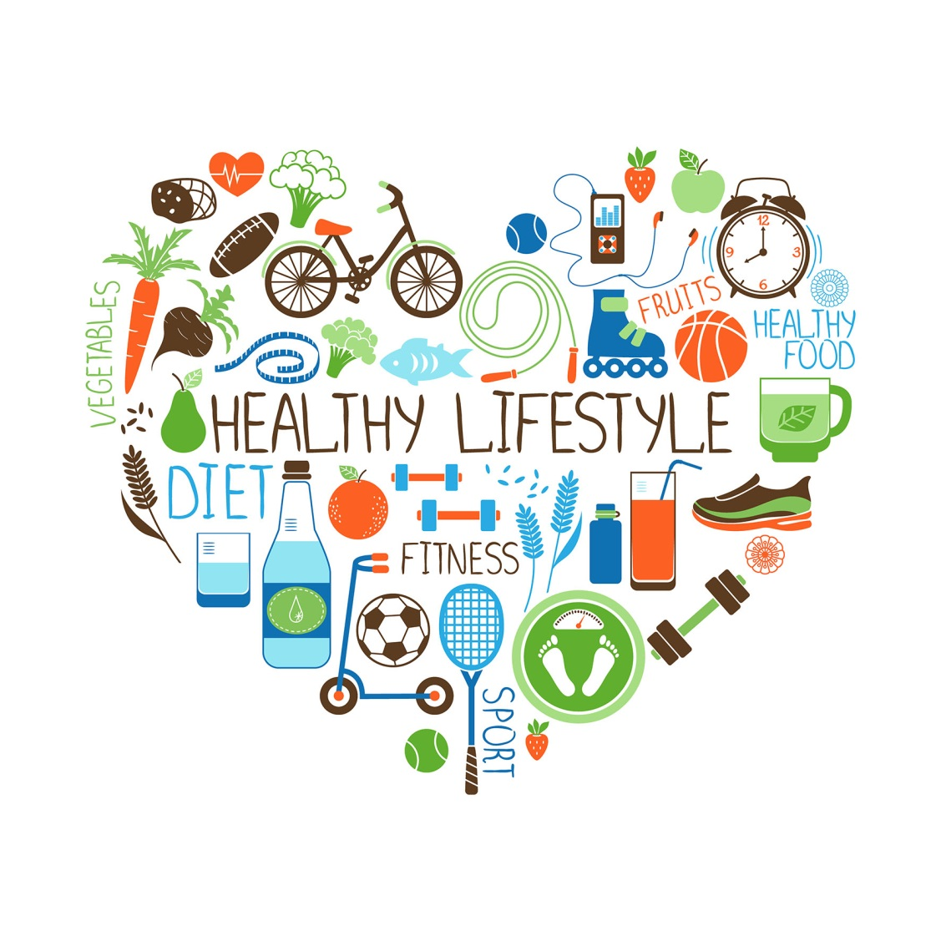

How we intend to work together to achieve this?

This Children, Young People and Families Plan does not exist in isolation, there are a number of other local area strategies aimed at achieving the priorities set out in this Plan.
Progress will be measured by focusing on the impact that the plan has on children, young people and families.

We will draw up a detailed Action Plan. This will take account of where we are now, what we plan to do, milestones along the way and who has responsibility to drive the key priorities forward.

Performance reporting on the action plan will be required at each Children’s Trust meeting.

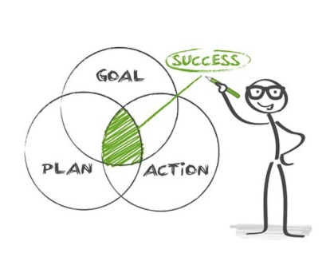

Respect and encourage the hopes and dreams of the children and young people we work with

Be child focussed, children and young people ae our primary concern

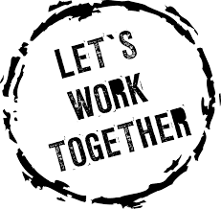
Be respectful of difference and celebrate diversity

Challenge poor practice and accept challenge constructively

Glossary
Term | Meaning
Black and Minority Ethnicity | Black and minority ethnicity (BME) is used to refer to members of non-white communities in the UK.
CAF | Common Assessment Framework. A nationally accepted approach to identify need and develop support for children and families. The framework incorporates the child’s development, parental capacity and social and environmental factors.
Children in Care (CiC) | In UK law children in care are referred to as 'looked after children'. A child is 'looked after' if they are in the care of the local authority for more than 24 hours.
Children in Need (CiN) | Children in need are defined in law as children who are aged under 18 and need local authority services to achieve or maintain a reasonable standard of health or development.
Child Protection Plans | A child protection plan is a plan drawn up by the local authority. It sets out how the child can be kept safe, how things can be made better for the family and what support they will need.
Closing the Gap | To reduce the difference between the least and most disadvantage.
Early Help | Providing the right help for families as soon as needs arise, to help prevent needs increasing. “Early” may be defined as early in the child’s life but may also be at the earliest point a problem has been identified, i.e. whenever a need arises regardless of the child/young person’s age.
Early Intervention | A range of services and resources to help families and children aged 0-19yrs. In Halton this is typically co-ordinated on a multi-agency basis through the CAF process.
Early Years | The period from pre-birth to pre-school. Services and support have a particular focus on 0-3yr olds and help for babies and toddlers with developmental delays or disabilities.
Integrated Commissioning | Working together to plan and fund outcome focused services for children and families that deliver high quality services that are value for money.
Integrated Contact and Referral Team (iCART) | iCART is the integrated front door to children and families’ services. The team is comprised of multi-agency staff, including social care, early intervention, education, health and Police, therefore there is access to a wide range of information.
Joint Strategic Needs Assessment (JSNA) | A Joint Strategic Needs Assessment (JSNA) looks at current and future health and care needs of local populations to inform and guide the planning and commissioning (buying) of health, well-being and social care services within a local authority area.
Local Safeguarding Children’s Board | A Local Safeguarding Children Board (LSCB) is a multi-agency body set up in every local authority. It has strategic role to play in protecting children in the local area.
Poverty | The state of being extremely poor.
SEND | Special Educational Needs and/or Disability. A child or young person of compulsory school age who has a significantly greater difficulty in learning or has a disability which prevents or hinders them from making use of educational facilities.
Voluntary Sector | The voluntary sector is very diverse, including multi-national charities, local community groups and everything in between.

Web: www.haltonchildrenstrust.co.uk
Email: CYPPolicy@halton.gov.uk
Twitter: @HaltonCT

