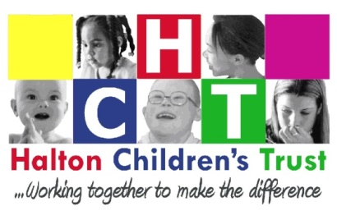
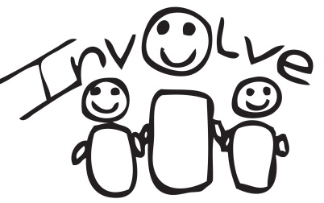

INVOLVE

MINUTES
23rd November 2015
(Actions are in Bold)

- At the meeting

Phil Mc Clure – Addaction, Youth Cabinet lead
Thomas Norris – Bright Sparks, HYC and Speak up not down
Leanne Gould
Vicky Jolly – NHS 5 Boroughs
Vikki Clarke – 14 -19 team
Haf Bell – 14-19 team
Michela Casey – Halton Carers centre
Rebecca Farell – Spoken and Heard, Young Carers
Michelle Forder - Lead engagement Officer Children’s Trust
John Hunt – Halton Speak Out
Chloe Buglass – Halton Family Voice Chair

- Could not attend
Ross McCooey – Core Assets
Matthew Walker – Youth Cabinet Representative
PC3501 Jane Tetlow – Cheshire Police
Chris Sweeting – YOS
Hannah Hague – peoples voice NHS England
Sara Jones – Participation lead CICC
Luke McDonald – Youth Volunteer, Addaction
Hannah Smith – 5 Star Forum
Chole Buglass – Halton Family Voice
Carl Harris – Halton Carers centre
Simon Price – CRMZ, Coordinator
Des Chow – engagement lead, Halton CCG

- What happened last time and matters arising

It was discussed at the last meeting about young commissioner training that John Bucknall had offered, training to be arranged for the end of January 2016. Members raised that before completing training it would be good if it was decided what trained young people would then take part in.ie: what is the role of young commissioner?, when they be part of commissioning process?, how often?. Members felt young commissioners who have completed training should be involved in more than just tender interviews. MF to ask JB and commissioning Partnership Board.

- 14-19 Team – Haf Bell
Dave Chisnall had previously attended INVOLVE to ask for advice on mentor and youth ambassadors. Dave has since left the team. Haf Bell and Vikki Clarke came to the group to update. The 14-19 team are responsible to track young people 16-19 and find out if they are in education, training or employment. They then can help and support young people who are not in education, employment or training (NEET) in finding courses and apprenticeships. This would also include YP in employment that offers no training or progression. The 14-19 team then need to report to the department for Education every month to update. The 14-19 team have caseworkers that refer YP to services and make sure they get the support they need. They also pay career connect formally connexions to have a walk in service at places like CRMZ where YP can get information and advice. They also have another service that go door knocking to try and find YP who are ‘unknown’ which means the local authority do not know if they are NEET or not. The 14-19 team asked involve for advice on how to advertise their services and the best way to reach YP to find out what they are doing and if they need help and support. They have been told previously by YP not to use leaflets as YP do not read them.

INVOLVE feedback that:

- leaflets are not a good way to communicate with YP
- Some YP use Facebook, but as there are now so many adults and parents on FB they are more likely to use Instagram and twitter and snap chat.
- When using Instagram use picture and write detail in the Bio.
- Using posters in lifts and on the back of toilet doors was a good way to communicate with YP, places where they are going to read as there is not much else to do. They also suggested library (teen section), job centres, rangers huts, park café’s and community centres.
- Using QR codes on posters that would take you to the website or social media is a good idea
- Digital posters should be used on social media rather than word status updates
- These posters should catch the eye (not be like the normal service posters) ie use popular and current themes such as star wars and mine craft
- Ask YP to share posts and ask YP to recommend as word of mouth is very powerful
- Use # to raise profile of a particular topic ie there is apprenticeships available

Haf also asked about the directory of provision and if YP would be interested in the document. It was thought that there shouldn’t be a big word document as they won’t read all the detail, instead we should produce a summary of the information through webpages so young people can click on what they are interested in quickly and easily

- INVOLVE Action Logs

Members looked at the action log, the 14/15 action log has now been completed and all feedback has been collected and there are no outstanding actions.

The outstanding areas are:

14-19 team – This section will be updated after today’s meeting.

Safeguarding - The Local safeguarding Children’s Board are due to meet this week to discuss a report written by Michelle on how to involve children and YP more using current INVOLVE network and developing a multi-agency participation hub, this would mean partners would work together and reduce duplication. TH will feedback on plans once meeting has taken place, meaning more participation work could be carried out.

Library – Nicola Lamb attended the last INVOLVE meeting Becca Farrell volunteers for the library and informed INVOLVE on a number of events the Library put on to encourage young people to use the library. BF will send these posters and information to MF to be distributed. BF to keep the group informed on library group activity.

Core assets – still have some outstanding feedback that MF will ask for

Other areas will feedback once they have carried out recommendations. INVOLVE did not want to add any actions at this time.

- AOB

Vicky Jolly Joined INVOLVE for the first time this evening she is responsible for the NHS 5 Boroughs SHOUT group. The group is to ensure young people’s voice is heard on mental health issues They have just held a successful participation event across the 5 boroughs (Halton, St Helens, Knowsley, Warrington, …). Vicky is now going to promote INVOLVE to the group and SHOUT will be part of the INVOLVE network.

The next Children’s Trust Board is on 17th December 4-6pm in Municipal Building, Widnes in the Board room. It was decided that Thomas Norris and Becca Farrell would attend from INVOLVE. Thomas will co-chair. PMc/MC will meet with Debbie Houghton and YP before meeting to go through agenda. Chloe Buglass will also be there as the chair of Halton Family Voice.

Next INVOLVE meeting is 28th January 2016 4-6pm
INVOLVE needs a Runcorn venue for the meeting, please contact Michelle if you have a venue that we could use.

