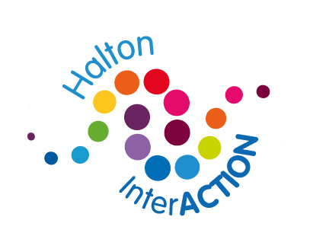

Halton INterAction Membership agreement
Halton INterAction is open to all voluntary sector organisations in the borough working with children and young people; including full time, part time and uniformed provision.
Meeting and events cover topical issues; such as funding applications, consortia opportunities, training needs, feedback from local Council developments.
Membership of Halton INterAction for youth is free of charge, but organisations are expected to fully commit to the overall aims, which include:
- Commitment to Halton Children’s Trust Board priorities
- Commitment to children, young peoples and parent/carers involvement at all levels within organisations and services
- Regular engagement with the forum through; attendance at Halton INterAction meetings, training and via facilitating officer of the forum.
- Respecting the work of other organisations and services for young people in the borough, avoiding duplication of provision.
- A commitment to collaborative working when this is in the best interests of young people.
- Working together to ensure the long term sustainability of children and young people’s provision.
- To act as an ambassador of Halton INterAction and to promote in a positive light
By registering for as a member of the Halton INterAction through email distribution or attendance at meetings you agree to the membership agreements.
The benefits of being a member of the forum are;
- Support in understanding and working to Halton Children’s Trust priorities, through training and networking events and opportunities for collaboration.
- Opportunities for collaborative working in the voluntary and community sector, developing quality provision to children and young people.
- Information about available funding and support in completing applications
- Access to foundation star standard to ensure organisations are fit for purpose and able to participate in funding applications or tendering.
- The development of partnership networks that share information, best practice and opportunities that benefit children and young people in Halton.
- Enabling voluntary sector organisations to be equal partners in the development and delivery of Halton Children’s Trust Board priorities through two way communication and through access to training and networking opportunities.

Halton INterAction Representation
Halton INterAction is supported by Halton Borough council and is an equal partner within Halton’s Children’s Trust. It is important that the forum is represented at key board meetings, this achieved through an allocated representatives at each of these meetings from Halton INterAction.
Voluntary sector representatives will be nominated and approved by networks and forums members. Where feasible, the voluntary sector will aim to seek to have 2 representatives to provide support to each other and to be able to cover for any absences.
Role Description
- To represent Halton INterAction on allocated meetings, where you are the named representative.
- Bringing together the views of Halton INteraction, in order to represent the relevant interests of parties at such meetings.
- Expressing the views and interests of the voluntary, Faith and community sector at such meetings.
- Providing a two-way information flow, between the partners and Halton INterAction, feeding back relevant information to the Halton INterAction and taking shared views and values of Halton INterAction back to such meetings. (This needs to be completed with the recognition that sensitive information may not be able to be shared outside of certain meetings).
- Reporting back to the Sector at Halton INterAction meetings and through other channels as appropriate. (using strategic links report card http://haltonchildrenstrust.co.uk/?p=675 )
Representatives agree:
- To attend allocated partnership meetings and Halton INterAction meetings regularly
- If they cannot attend they must send apologies, if this is a prolonged period you are unable to attend please inform Halton INterAction lead officer, a replacement can then be arranged.
- In cooperation with Halton INterAction; to seek to express and promote the views and interests of the Halton INterAction. Achieved by identifying opportunities to table agenda items for partner discussion, and highlighting opportunities to CYP VSF for further partnership working.
- Be clear about Halton INterAction‘s objectives (stated in membership agreement) and support them with a strong evidence base. Representing the Halton INterAction in a fair and constructive manner as an ambassador of the Halton INterAction.
- To uphold an independent role of the Halton INterAction and maintain a non-partisan position in relation to issues under consideration
Any grievance about a representative should be taken up with the representative in the first instance. If the issue cannot be resolved then contact should be made with HBC engagement lead. If there is no resolution this will be raised at with Halton INterAction and the representative may be asked to give up their role and a new rep will be identified. As the named representative for the Halton INterAction at meetings you agree to the above 5 points.

